**COMP 302: Software Engineering**

**Team:** CizikCizik

Final Report

Group Members:

Arda Burak Yeni

Alperen Us

Ebubekir Karamustafa

Emirhan Çakır

Mahmut İbrahim Deniz

Metehan Yaka

Table Of Contents

Introduction and Vision 2

Teamwork Organization 3

UML Use Case Diagram 4

Use Cases 5

System Sequence Diagrams 11

Operation Contracts 16

Interaction Diagrams 18

UML Class Diagram 20

Package Diagram 20

Supplementary Specifications 20

Glossary 24

Introduction and Vision

**Introduction**

We aim to create a fantastic board-game based on alchemy.

**Vision**

KU Alchemists is a fantastic board game that immerses players in a magical world where they must solve the riddles of magical ingredients and potions to become better alchemists. Gamers hope to experience an immersive board game while being strategically and intellectually challenged. Their objectives are to become the top alchemist, grasp the game's mechanics, and become an expert at deduction within the game. Alchemists, an impressive and difficult strategy game for board game enthusiasts, aims to give users a fantastic gaming experience. strategically and intellectually challenged. Their objectives are to become the top alchemist, grasp the game's mechanics, and become an expert at deduction within the game. Alchemists, an impressive and difficult strategy game for board game enthusiasts, aims to give users a fantastic gaming experience.

Teamwork Organization

Throughout the project, we worked as two teams, backend and frontend, as if we were a real software development team. The purpose of this was to ensure specialization in certain subjects. For example, while someone on the backend team was not an expert on a UI object, someone on the UI side did not need to be an expert on the logic used in the backend. Another benefit of this was that it made it imperative for us to stick to model-view separation. Of course, we progressed through many stages of the project in a full-stack manner, helping each other, but in general, we tried to clearly define the areas for which we were responsible.

## **Members**:

**Backend Team:**

* Ebubekir Karamustafa (Game Logic - Network - Design Pattern Expert)
* Metehan Yaka (Project Setup - Game Logic - Network - DBA)
* Alperen Us (Game Logic)

**Frontend Team:**

* Emirhan Çakır
* Arda Burak Yeni (UI & Controller Designer - Bugfixer)
* Mahmut İbrahim Deniz

## **Week by Week Responsibilities:**

In the first two weeks, all members of the team spent time understanding the basics of the projects, and dynamics of the Alchemist Game. Some rules of the game were unclear and some concepts were hard to design in code. Hence, all team members worked on game instructions and plans.

In week 3, Arda and Mete wrote the vision of the project. Alperen and Ebubekir prepared the supplementary specification of the project. Emirhan and Mahmut prepared the glossary of the project. The whole team spent time creating interaction diagrams and GitHub Setup.

In week 4, the whole team finalized the UML class diagram, communication diagrams, sequence diagrams, and the logical architecture of the project.

In weeks 5-6, Ebubekir handled the Potion Brewing Area & Player Switching Mechanism for the backend. Metehan handled Ingredient Storage and Related Backend Operations and left the backend mechanism. Alperen handled the Publication Track Backend. Mahmut handled the Use Artifact and Buy Artifact UI Design and determined Backend Operation requirements. Emirhan handled Inventory UI Design and Arda handled the Deduction Board UI Design

In week 7, Ebubekir handled the Make Experiment Backend & SceneManager Observer Pattern Implementation & Game Tour & Round Mechanism. Metehan handled Help Screen Backend Finalize & Sell Potions Backend & Game Over, Scoring, Gold Update Backend. Alperen handled Publish & Debunk Theory Backend, Artifact Backend Finalize & Player Creation & Avatar Selection Backend. Mahmut handled Sell Potion UI. Emirhan handled Debunk UI. Arda handled Publish Theory UI

In week 8, Arda did Menu enhancements + TheoryUI+ final scoringUI. Mete handled Sell Potions + Player fields ui update(observer) + Help Screen. Mahmut did Sell Potion UI + Final Screen UI + Sell Potion Use Case. Emirhan did Game Tour Mechanism UI Endorse UI. Ebubekir did Make Experiment Backend + GameRound&Tour & GameOver Mechanism. Alperen did Theory backend + use case

In week 9, Mete and Ebubekir worked on SceneLoader MVC Issue + Avatar Select UI & Backend & Multiple Users Backend & UI integration+ Game Init Refactoring+ Endorse Backend. Mete and Mahmut worked on Game Over UI, and Final Score UI. Arda worked on Online&OfflineUI &Avatar Select UI & Number of Players UI. Emirhan worked on Board UI Draft +Endorse UI Finish+Help Screen Bugfix. Arda and Alperen did Publish Theory Bugfix+ Debunk Service

In week 10, Arda worked on the Finalization of the Publication Track & Publish theory enhancement. Mete worked on Online & ApplicationMode Integration Backend & UI. Mahmut worked on Sound UI & Backend. Emirhan worked on Finish Board UI + Test Draft. Ebubekir worked on Online & Endorse and Publish Integration + Testing

. Alperen worked on Online + New Artifacts + Publish Endorse Integration

In week 11, Mete worked on Responsibilities about Online & Scoring / Refine existing tests. Mahmut worked on Sound(additional sound effects) + Magic Mortar UI + Printing Press UI + BuyArtifact UI(Additional Artifacts) + UseArtifactUI(Additional Artifacts). Emirhan, Alperen, and Ebubekir worked on Publication Track & Publish Theory & Endorse  UI & Backend Integration. Ebubekir worked on Online Game Initialization & Event Manager Init Bug & Server-Client Commn. & Publish & Debunk Theory Integration

& Adapter Pattern Implementation. Arda worked on the Online game lobby.

You may find the weekly agendas in the Appendix

UML Use Case Diagram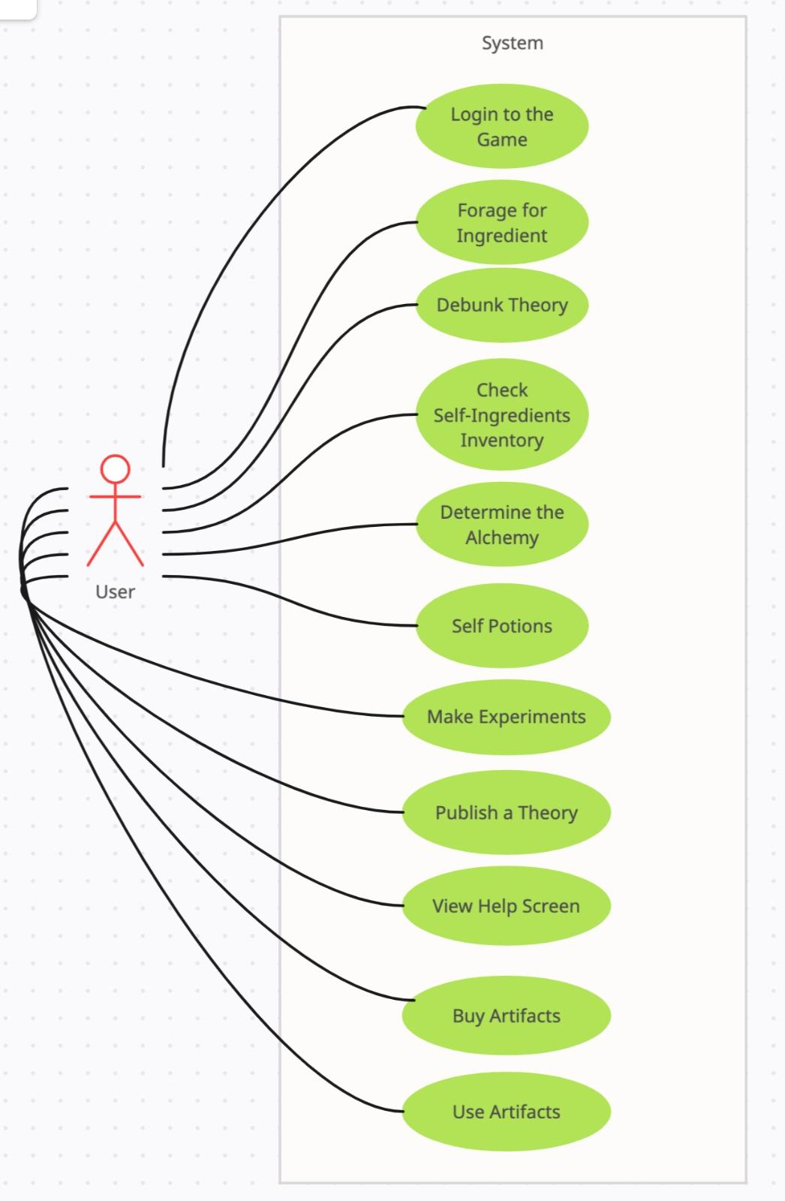

Use Cases

**Use Case 1: Debunk Theory**

**Use Case ID**: UC-A3

**Scope**: KU Players-Phase 1

**Level:** User goal

**Primary Actor:** Player

**Stakeholders and Interests:**

-Player: wants to gain a reputation through debunking the suspicious publication.

**Preconditions**:

* The game is in the final round and there is at least 1 published theory.

**Postconditions:**

* If the theory is debunked, the player gains reputation, otherwise, they lose reputation.

**Main Success Scenario:**

1. The player selects a published theory they wish to debunk.
2. The player chooses one specific aspect which could be incorrect.
3. The system displays the sign of that aspect of the theory. The system indicates whether the sign is correct or not.
4. The signed token is matched, and the player has successfully debunked the theory and gains 2 points of reputation.
5. Remove the theory from the theory board.
6. Players who use an unstarred seal lose no points if the color behind the question mark matches the aspect that was used to debunk the theory.
7. All seals that were on that theory are removed from play.
8. The result is shared with the community and reputations are updated.

**Extensions:**

**4a.** The token isn’t matched.

   1. The player loses 1 reputation point.

**4b.**  Players debunk publications with 1 reputation.

1.If the sign of aspect theory is matched, the player loses 0 reputation points.

**6a.** Players who used a starred seal.

1. They lose 5 points of reputation.

**Special Requirements:**

* Special UI window to access published theories and their alchemical tokens for comparison.

**Frequency of Occurrence:**

In the final round, players have the opportunity to debunk theories published by others. The number of theories a player can debunk is determined by their available action points.

**Use Case 2: Check IngredientStorage**

**Use Case Name:** Checking Inventory

**Use Case ID:** UC-4

**Scope:** KU Players-Phase 1

**Level:** User goal

**Primary Actor:** Player

**Stakeholders and Interests:**

* Player: Wants to review the contents of their ingredient inventory.

**Preconditions:**

* The game must be set up, and two ingredients should have been distributed among the players.

**Postconditions:**

* The Player successfully checks their ingredient inventory.

**Main Success Scenario:**

1. The Player, during their turn, wishes to review the ingredients they possess.
2. The Player opens the inventory and examines the ingredients.

**Extensions:**

**2a.**  Attempt to open inventory before the game is settled.

1. The system displays a warning message indicating that the game needs to be set up before checking the inventory.

**Special Requirements**

* The player uses an inventory window to view ingredients.

**Technology and Data Variations List:**

**Frequency of Occurrence:**

* A Player may access their inventory when it's their turn and after the game has been set up.

**Use Case 3: Use Artifact**

**Use Case ID:** UC-A11

**Scope:** KU Alchemists-Phase 1

**Level:** User Goal

**Primary Actor:** Player

**Stakeholders and Interests:**

* Player: Wants to use their artifact(s) in their inventory to increase their power to gain advantages over the other user(s).

**Preconditions:**

* Player(s) need to have the artifact(s) in their inventory to use them. To add artifacts to their inventories, they have to buy them from the Buy Artifact.

**Postconditions:**

* The player will have more power than they had and get more advantages over the other player.

**Main Success Scenario:**

**1.** The player searches artifacts that they have bought and examines which artifact is necessary for them to take advantage of other players at that moment.

**2.** The player selects one or more artifacts from their inventory to use them simultaneously.

**3.** After using these artifacts, the player will advantages that they may change the dynamics of the game.

**Extensions**

**\*a.** During the using phase, the using procedure may fail:

1. System gives an error message to the user that identifies the problem.

**2a.** Players may change their minds and cancel using artifacts:

1. Game will continue without changing any data of the user.

**3a.** The player may want to use some artifacts, but the artifacts may not be in the inventory:

1. System will not allow to select the artifacts that they do not have to use.
2. Player can continue to buy the artifact(s) on the Buy Artifact, then use in the Use Artifact.

**Special Requirements**

* Users need to be sure before they use artifacts as the using procedure is irrecoverable.

**Frequency of Occurrence:**

* Happens every time the user wants to use some artifacts they have.

**Use Case 4: Buy Artifact**

**Use Case ID:** UC-A10

**Scope:** KU Alchemists-Phase 1

**Level:** User Goal

**Primary Actor:** Player

**Stakeholders and Interests:**

* Player: Players want to buy artifacts to increase their abilities and gain more power and advantages.

**Preconditions:**

* Players need enough money to purchase artifacts.

**Postconditions:**

* The player will have artifacts to use later.

**Main Success Scenario:**

1.      The player searches artifacts and examines which artifact is necessary for them to take advantage of at that time.

2.     The player examines the properties of artifacts to choose the optimum of price and power to increase their strategic advantages.

3.    A player can purchase more than one artifact at the same time. The player can select multiple or single artifacts and add them to their shopping cart to pay for all of them at once.

4.    Players pay for the artifacts that they want to have. In that time system runs the payment procedure to make payment successful.

5.     Player receives their artifacts which are paid for.

**Extensions:**

**\*a. System Failure:**

1-During the paying phase, the payment procedure may fail and terminate:

1. The system gives an error message that identifies the problem

**3a.** The player may want to buy some artifacts that they already have:

1. The system will not allow the user to select the already bought artifact(s) to buy them again.

**3-5a.** The player may cancel their orders in the cart and the system terminates the whole buying artifact case:

1. Game will continue without changing any data of the user.

**5a.** The player may try to buy some artifacts that are not available at that time for the user:

1. System gives a message to remind the user that they cannot use some specific artifact(s).
2. Player can continue selecting other artifact(s) to use.

**Special Requirements:**

* Users need to be sure their purchases before they finish the buying phase as buying process is irrevocable.

**Frequency of Occurrence:**

* Happens every time the user wants to buy some artifacts.
* When a user wants to look for details of artifacts

**Use Case 5: Publish a Theory**

**Use Case ID**: UC-A8

**Scope**: KU Alchemists-Phase 1

**Level**: User Goal

**Primary Actor**: Player

**Stakeholders and Interests**:

* Player: Wants to publish a theory about an ingredient's alchemy, paying 1 gold to the bank.

**Preconditions**:

* The game is in the second round or third round.
* The player has a theory to publish and it's their turn.
* The theory should not have been published before by someone else.

**Postconditions**:

* The player's theory is displayed on the publication track area of every player and they gain 1 point of reputation.

**Main Success Scenario:**

1. The player opens the theory publishing screen.
2. The player selects the ingredient they want to publish a theory about.
3. The player enters the predicted alchemies into the system.
4. The player pays 1 gold piece to the bank as a publishing fee.
5. The player gains 1 point of reputation and contributes to the collective knowledge of the alchemical community.
6. The published theory is added to the publication tracking area.

**Extensions:**

*a. At any time, the system could fail.

4a**.** If the player does not have sufficient gold to pay the publishing fee:

1. Display an error message informing the player they don’t have enough gold to publish their theory.

2. The player's turn continues without publishing the theory.

**Special Requirements:**

1. The system should be capable of updating the player's gold amount in real time.
2. The system must notify all players when a new theory is published on the publication track area.
3. The reputation system should immediately reflect the changes for each player after the theory is published.

**Frequency of Occurrence:**

* During each player's turn, with the possibility of multiple occurrences per game session, especially in longer games or games with more players.

System Sequence Diagrams

SSD 1: Use Artifact

metin, ekran görüntüsü, yazı tipi, çizgi içeren bir resim

Açıklama otomatik olarak oluşturuldu

SSD2: Debunk Theory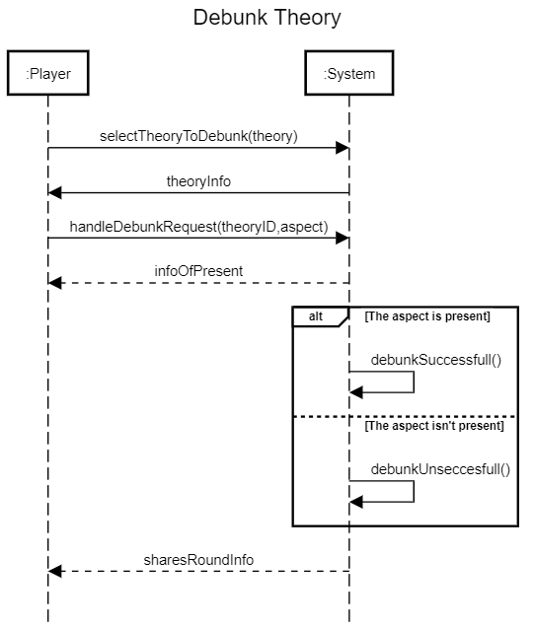

SSD3:Make Experiment

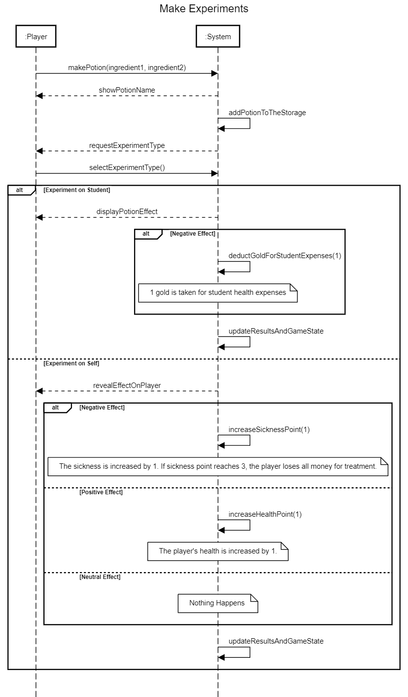

SSD4: Sell Potion

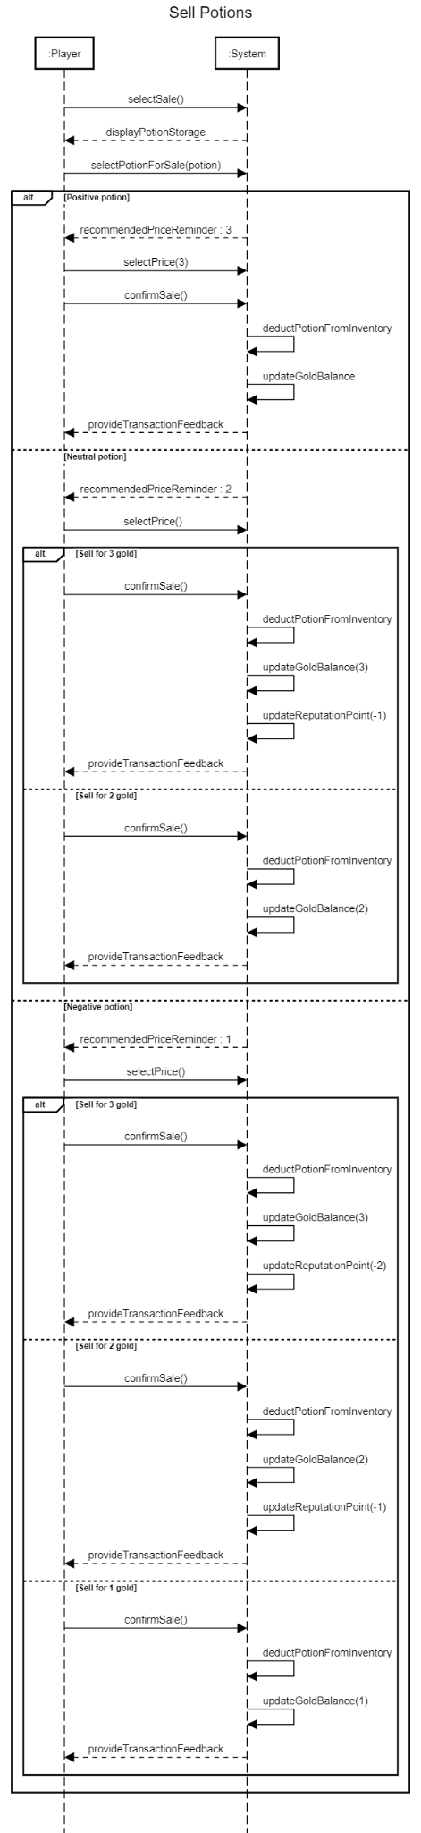

SSD5: Publish Theory

metin, diyagram, ekran görüntüsü, paralel içeren bir resim

Açıklama otomatik olarak oluşturuldu

Operation Contracts

**Contract CO1: Buy Artifact**

**Operation:** getBoughtArtifacts()

**References**: Use Cases: Use Artifact

**Preconditions**: The user should click on Use Artifact button on the main board.

**Postconditions**:

* This method will be called each time the user clicks on Buy Artifact button on the main board.
* The user will be able to use artifact(s) if it is bought.

**Contract CO2: selectTheoryToDebunk**

**Operation: selectTheoryToDebunk(Theory: theory)**

**References**: Use Cases: Debunk Theory

**Preconditions**: The game is in the final round and there is at least 1 published theory. The current player should have at least 1 action point.

**Contract CO3: Enter Predicted Alchemicals**

**Operation:** enterPredictedAlchemicals()

**References**: Use Cases: Publish a Theory

**Preconditions**: The theory publishing area was opened and ingredient was selected.

**Postconditions**:

* A Alchemical instance a was created.
* A Theory instance t was created.
* t.predictedAlchemical was associated with the a

**Contract CO4:**

**Buy Artifact**

**Operation:** buyArtifact(artifactName)

**References**: Use Cases: Buy Artifact

**Preconditions**: The user have to select at least one artifact to buy. This function takes one string parameter that holds the name of the artifact willin to be bought.

**Postconditions**:

* The method will be called for each selected artifact one by one.
* The user will have the artifact in case they have enough money.

**Contract CO5: Use Artifact**

**Operation:** useArtifacts()

**References**: Use Cases: Use Artifact

**Preconditions**: The user should click on Use Artifact button on the main board.

**Postconditions**:

* This method will be called each time the user clicks on Buy Artifact button on the main board.
* The user will not be able to buy an artifact if it is bought already.

Interaction Diagrams

**Sequence Diagram 1: Debunk Theory**

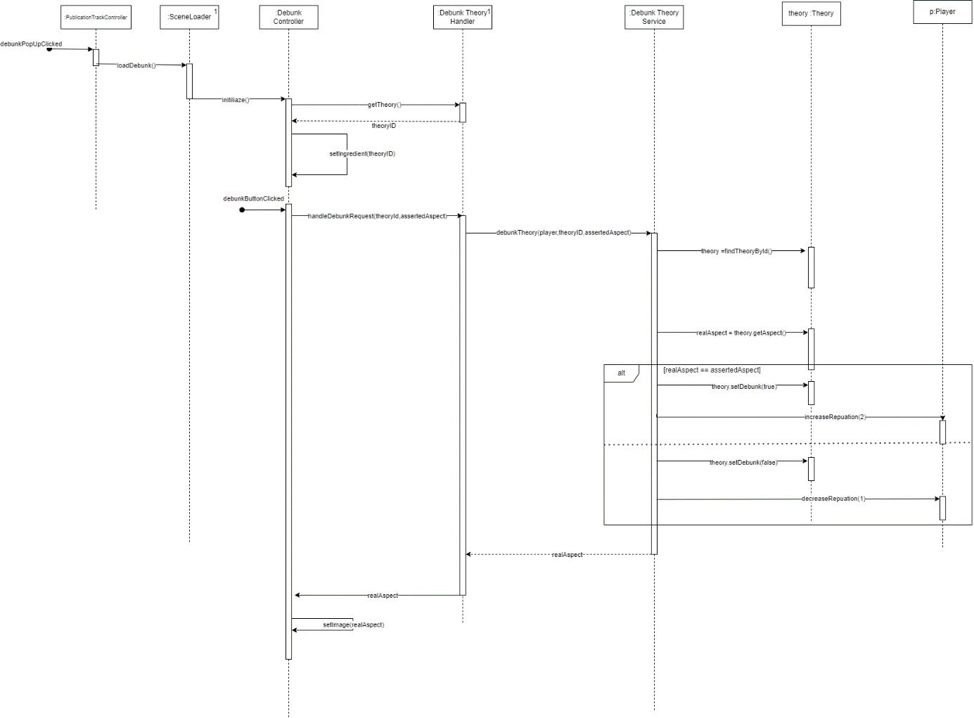

**Communication Diagram 1: Debunk Theory**

makbuz, metin, diyagram, çizgi içeren bir resim

Açıklama otomatik olarak oluşturuldu

**Sequence Diagram 2:Buy Artifact**

metin, diyagram, paralel, plan içeren bir resim

Açıklama otomatik olarak oluşturuldu

**Communication Diagram 2:Buy Artifact**

metin, makbuz, ekran görüntüsü, çizgi içeren bir resim

Açıklama otomatik olarak oluşturuldu

**Sequence Diagram 3:Forage the Ingredient**

metin, makbuz, çizgi, diyagram içeren bir resim

Açıklama otomatik olarak oluşturuldu

**Communication Diagram 3:Forage the Ingredient**

metin, makbuz, ekran görüntüsü, çizgi içeren bir resim

Açıklama otomatik olarak oluşturuldu

UML Class Diagram

metin, diyagram, plan, paralel içeren bir resim

Açıklama otomatik olarak oluşturuldu

Package Diagram

metin, çizgi, makbuz, yazı tipi içeren bir resim

Açıklama otomatik olarak oluşturuldu

Discussion of Design Pattern and Principles

Supplementary Specifications

## Introduction

This document is the repository of all KU Alchemists requirements that are not captured in the use cases.

## Functionality

The System does actions in the game. For example; displaying the player’s inventory, showing ingredient and potion information. The details are explained in Application-Specific Domain Rules.

## Logging and Error Handling

Log all errors to persistent storage.

## Security

All usage requires user authentication at the beginning of the game. (Login Page)

## Usability

*Human Factors*

The players should be able to see and understand the game objects and their interactions with the game board. Therefore:

* The visuals of game objects should be compatible with the design of the game
* Avoid colors associated with common forms of color blindness.
* Interactable areas (e.g. the Foraging area in the First Round) on the board should be identifiable and clear to the player. The organization of the game board in each round is crucial.
* All texts and graphics should be identifiable and readable to the player from a distance of 50 cm.

## Reliability

*Recoverability*

If there is a failure to interact with the system, try to save the current game progress into the local game folders and reset the game. The user will be able to continue playing from where they left off in the previous game.

## Performance

Players want to have an engaging gameplay experience. Therefore, the player must be able to interact with game objects quickly without error or confusion. There should not be any delay between architectural layers (e.g. UI layer responds very slowly to change in the domain layer).  Our goal: maximize engagement and gameplay experience by optimizing performance time.

## Supportability

*Adaptability*

Different players of the KU Alchemists Game will have a unique gameplay experience. However, the rules are the same for every player. Therefore, the game is adaptable to every scenario by default.

*Configurability*

Different players will have different preferences in each round. For instance, one player might prefer to forage for ingredients while the other player might prefer to buy ingredients. Therefore, the system will be somewhat configurable to reflect the different needs of players. UI should be configurable to the needs of players in line with the game rules. Our goal: provide a user-friendly and configurable game environment.

## Implementation Constraints

Group Çizik Çizik uses Java and built-in Java libraries such as javaSwing and JavaSQL to implement the KU Alchemists Project.

## Free Open Source Components

We want to maximize the use of free Java open-source software components on this project. We might also use open-source assets for game design elements.

Application-Specific Domain Rules

The game mostly follows the rules of the original board game, Alchemists. See the link for detailed rules. <https://www.czechgames.com/files/rules/alchemists-rules-en.pdf>

*General Rules*

The game consists of three rounds. In each round, the player has three action points. Each round includes new action types for players to use. Once entered a new round, the player can use action types unlocked from previous phases.

First Round

In the first round, there are four action types:

1. Players can draw 1 ingredient card from the deck at the beginning of the round.
2. Players can discard 1 ingredient card and take 1 gold.
3. Players can buy artifacts.

* Players pay 3 golds to take one card from the artifact deck.
* Artifacts taken by the player can be seen by other players.
* Players can also use their artifacts and don't use additional action points.

Artifacts can have:

* Permanent effects that last the entire game.
* Temporary effects can be used only once in the game unless you draw the same card and use its effect.

1. Players can make experiments.

* Players mix two ingredients to make potions.
* Players can try the results of the experiments on his/her students or themselves.
  + The player chooses the type of the experiment. The potions can be experimented on students and themselves.
    - If the player chooses to experiment with the potion on students;
      * If the potion is positive or neutral, the player sees the effect of the potion
      * If the potion is negative, the player sees the effect of the potion and also pays 1 gold for students' health expenses.
    - If the player chooses to experiment on him/herself;
      * If it is positive, the player sees the effect of the potion.
      * If it is neutral, the player is not affected.
      * If it is negative, the player’s sickness is increased by 1. When the sickness point reaches 3, the player loses all of his/her money to get treatment.

Second Round

In the second round, there are two action types.

1. Players can sell potions.

* Players sell potions to the adventurer in the range of 1-3 golds.
  + The player earns 3 golds for positive potions.
  + The player earns 2 golds for neutral potions.
  + The player earns 1 gold for negative potions.

1. Players can publish a theory.

* The player publishes a theory about an ingredient.
* The player chooses an alchemy marker and places it on an available book on the theory board.
* The player pays 1 gold piece to the bank as a publishing fee.
  + The player cannot publish a theory if he does not have any gold.
* The player gains 1 reputation point for publishing a theory.
  + Theories can be debunked (look final round)

Final Round

In the final round, there is only one action type.

1. Players can debunk a theory.

* The player selects a published theory he suspects.
* The player chooses an aspect of the theory.
  + If the theory is correct, the player loses 1 reputation point.
    - If the player has 1 reputation point, he loses 0 reputation points
  + If not, the player gains 2 reputation points.

Final Scoring

The player with the maximum score points wins the game.

* One Reputation gives 10 score points.
* One Artifact gives 2 gold.
* Three gold gives 1 score points.
* If there is a tie, the tiebreaker is gold.

Glossary

**Alchemist**: A player in the game who tries to find secrets of magical ingredients and create powerful potions.

**Ingredient**: A game element used by alchemists to create potions. Examples include feathers and mushrooms.

**Potion**: A primary objective in the game, created by combining ingredients. Represented as cards with recipes and point values.

**Theory**: Cards representing theories or publications that players can contribute to, each with specific requirements and point values.

**Artifact Card**: Special cards offering players unique abilities or effects throughout the game.

**Alchemical**: Alchemicals consist of three aspects which are green, red, and blue. Each ingredient corresponds to one alchemical.

**Deduction Board**: A board area where players place alchemy markers to form and test ingredient property theories.

**Aspect**: Aspects consist of two sides “-” and “+” and three types. Aspects can be green, red, and blue.

**Reputation**: Each player has a reputation in Alchemy University. This reputation is gained by publishing theory and debunking theory.

**Gold**: It is money in the game to use in transactions such as selling potions or buying artifacts.

**Adventurer**: It is a role that buys created potions.

**Student**: It is a helper for alchemists. Alchemists could try their experiments on students.